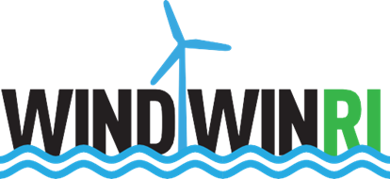

Fast Facts about Offshore Wind Northeast Region Market

- The Northeast Coastal Corridor of the United States has significant technical potential for the deployment of offshore wind power generation.
- As of 2019, there are 20GW of offshore wind projects under permit review along the Atlantic coast between Long Island and Cape Cod. 1GW can power up to 700,000 homes.
- A U. S. Department of Energy Analysis of Offshore Wind Farm development and job creation along the Northeast Coastal Corridor released in October, 2017 projected “In the low scenario, wind energy economic activity will translate to 160,000 baseline full-time equivalent (FTE) job years over the lifetime of the wind farms, with a peak of 8,300 FTE jobs in 2028. In the high scenario there would be a total of 320,000 baseline FTE job years, with a peak of 16,700 FTE jobs in 2028.”
- A May 2017 Analysis of Offshore Wind Energy Occupations in Rhode Island found occupations that will most likely be in demand include engineering services, electrical contracting, welding, construction equipment operators, and general operations.

Rhode Island Offshore Wind Companies:
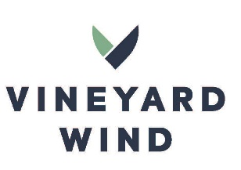 | 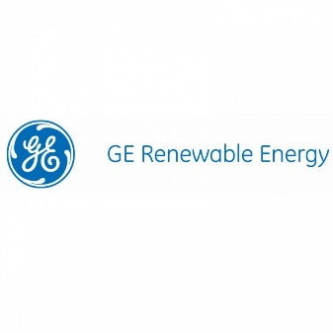
Vineyard Wind, LLC  https://www.vineyardwind.com/ | GE Renewable Energy  https://www.ge.com/renewableenergy | Ørsted North America  https://orsted.com/ | Field Core  https://www.fieldcore.com/

Examples of jobs in Offshore Wind
Job Title:  Offshore cable installation engineer | Field Specialist - Uptower Repair | Senior Project Planner | Mechanical Technician
Duties: Project Engineering in relation to all installation activities and the contractor’s installation (and pre-installation engineering) works. | To complete maintenance and large component replacement, troubleshoot mechanical and/or electrical repairs, oversee contractors, and repair wind turbine generators. | Time management, resource planning and implementation of standardized processes. | Safely accomplish the installation, maintenance and repair of Offshore Turbines.
Typical salary range:  $50-$90K Annually | $50-$75K Annually | $50-$90K Annually | $50-$75K Annually
Level of Education needed:  - Bachelor’s degree in Electrical Engineering and five years relevant experience in offshore cable installation activities. | - High School Diploma / GED  - Completion of Certificate / Associates / Bachelors Degree in a relative field, including, but not limited to: electrical, mechanical, Renewable Energy | - College 2-4 Years  - Completion of Certificate / Associates / Bachelors Degree in a relative field, including, but not limited to: electrical, mechanical, Renewable Energy | - High School Diploma / GED  - Completion of Certificate / Associates / Bachelors Degree in a relative field, including, but not limited to: electrical, mechanical, Renewable Energy

To prepare for a job in INDUSTRY while in High School and beyond:
Sample Coursework: | Work-Based Learning opportunities: | Industry-recognized Credentials to earn: | Skills to build:
WINDWIN RI is collaborating with North Kingston High School and RIDE in the design and implementation of a Offshore Wind Energy Certificate for High School Students. Pawtucket (Shea), Block Island and Rocky Hill are slated to implemented in the fall of 2019.
High School:  - Principles of Engineering or Engineering Essentials (PLTW) or Engineering & Technology (CCRI)  - Environmental Science  - Marine Safety  - Engineering Design & Development (PLTW) - Engineering Capstone | High School Field Trips:  - Narrated Boat to visit Block Island Wind Farm  - URI – Coastal Resource Center  - 80 hrs. industry internship | Certifications High School:  - USCG – STCW-10 Marine Safety or GWO Marine Safety (Fire module after age 18)  Post-Secondary:  - SPRAT – Working at Heights Training | Essential Skills”  - Engineering concepts  - Power  - Renewable Energy  - Environmental: wind, water, effect on wild life

Opportunities to learn more about INDUSTRY in Rhode Island:
Resource | Description
State of Rhode Island Office of Energy Resources  http://www.energy.ri.gov/ | The Office of Energy Resources (OER) is Rhode Island’s lead state agency on energy policy and programs.
Real Jobs RI  http://www.dlt.ri.gov/realjobs/ | Real Jobs RI is a demand-driven, workforce and economic development initiative that is collaborative, flexible and business-led.
WINDWINRI | The North Kingstown Chamber of Commerce is the leader of a consortium of economic development, education and business partners dedicated to designing and implementing a strategic, demand-driven career pathway system for offshore wind sector.

Kristin Urbach at 401.295.5566 or kurbach@northkingstown.com

